TOORMINA PUBLIC SCHOOL

N E W S L E T T E R

NEWSLETTER 35/09 – Week 5, Term 4 – 17th November 2009

Dear Toormina Families
It is hard to believe that we have reached the middle of the term but we have. Students are engaged in completing assessments while teachers are busy with reports. Many events are scheduled to complete the year and planning is under way for these.

Our new school website is up and running. The Department of Education and Training (DET) has a new facility to host school websites and we have included ourselves in its rollout. It contains both our school content and also information provided by DET. As staff become more familiar with the processes we will use this medium to inform you of school events as they happen, coming events and general information. There is a news section as well as galleries. Our weekly newsletter will be posted as well as the school calendar. There is a section for teachers to report on classroom activities. The website can be accessed by Googling “Toormina Public School” or by entering the address http://www.toormina-p.schools.nsw.edu.au. This facility will enable us to inform you of the very latest news such as when an excursion is due to return.

At this time it is appropriate to check with parents that they are happy for their children’s pictures to appear on our website. We already have a list of names but now it would be appropriate to check again. When students enrol we ask parents to indicate if they are happy for their child’s image to appear in a variety of media. If you DO NOT want your child’s picture on our website please contact the school and inform us.

Last week two teams of chess players attended an inter school competition. These students have been honing their skills in lunchtime sessions throughout the year. They have entered a number of competitions during the year and are doing very well. This time both our first and second teams were placed second in their divisions. Our second team of Natalie Hawkins, Mark West and Clyde Fisher brought back a medal of which they are very proud while the other team of Trung Bui, Billy Ensbey and Cody Bland brought back a trophy. We are very grateful for the assistance of retired school principal, Mr George Gelagin, who has given many hours coaching and encouraging the students and organising our participation in these competitions.

The students who participated in the Bongil Bongil Public Speaking Competition reported it was a great experience. It was fantastic when you consider that even Stage One and kindergarten were involved.

Andrew Bagust
Relieving Principal



TOORMINA PUBLIC SCHOOL
Truth and Tolerance

ADDRESS:
CAVANBA ROAD,
TOORMINA NSW 2452

TELEPHONE: (02) 6653 2122
FACSIMILE: (02) 6658 2287

EMAIL:
Toormina-p.school@det.nsw.edu.au

WEBSITE:
www.toormina-p.schools.nsw.edu.au

PARENTS & CITIZENS ASSOCIATION

P & C Committee meets
1st Friday of each month
9.15 am in School Staffroom

WHAT’S ON !

- Thursday 19.11.09
Swim Fun – Y6 /Y5

- Friday 20.11.09
Stage 2 AFL

- Friday 20.11.09
BIG Bike Ride

- 25/26/27.11.09
School Spectacular – Senior Choir

- Thursday 26.11.09
Swim Fun – Y6 / Y5

- Friday 27.11.09
Stage 2 AFL

- 30.11.09 – 4.12.09
Y6 Canberra Excursion

STUDENT AWARDS:

- Gotcha Being Good
Max Sagaris 1C

- Collect-a-Cap …
Ben Wallace KB
Calum Reid KB

CONGRATULATIONS to the above students

(Prizes generously donated by Domino’s Pizza, Eagle Boys Pizza and the School Canteen – Thankyou!)

Club 1000
“Honour List”

CONGRATULATIONS to the following achievers:
Layla Jackson KC
Tarrant Munday KL
Jennifer Peyto 3T
Gerard Purton 2K
Jayd Schutt 2K
Brent Fairbairn 2K
Giselle Birtwistle 2K

Club 2000
“Honour List”

CONGRATULATIONS to the following achievers:
Shaylee Holmes 2K
Luke Zerbe 3/4K

CHESS
Nine of our chess players represented Toormina Public School at the Three Persons Tournament held at the Coffs Harbour Catholic Club, last Wednesday 11th November.

Justin Pryce, Trung Bui and Cody Bland competed in A grade where they really excelled, coming second overall. Our chess coach, Mr George Gelagin reported that it was a powerful team effort with all players scoring well. Trung displayed a rising talent in chess, winning ten out of his eleven games. Jay Shipman, Billy Ensbey and Jaden Keenes also competed in A grade doing very well and playing some very strong chess.

Clyde Fisher, Mark West and Natalie Hawkins, competing in B grade, also played very competitively gaining silver medals. Mark and Natalie are only in Year 4 and Mr Gelagin feels that they will be a force to be reckoned with next year. Mark was the only player of the tournament to win all of his twelve games.

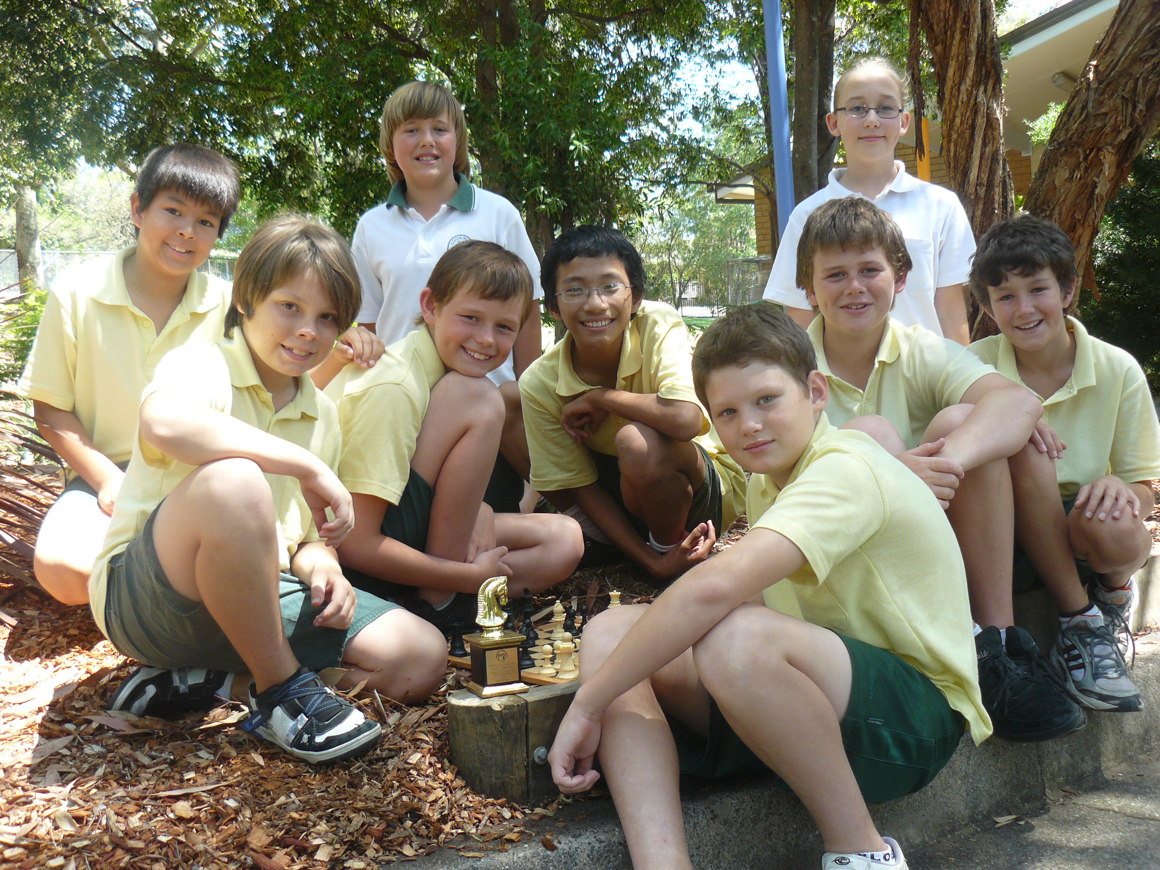

Congratulations to all of these students and a huge thank you to Mr Gelagin for his coaching and mentoring role. Special thanks also to Mrs Bland, Mr West and Mrs Hawkins for providing transport on the day and to the other parents present for their encouragement and support of our students.
Elizabeth Paff

BIG BIKE RIDE Year 5 and 6

Don’t forget the Big Bike Ride is this Friday for all Year 5 and Year 6 students.
Please return the permission notes if you haven’t already done so.

We’ll be checking bikes at 9.15 am and hopefully leaving by 10 am.
L. Newland

P & C NEWS
Hi everyone,

We are about four weeks away from holidays. Coming up on the 9th December is our last Disco for the year. This will be an evening event, more on that next week.

Raffle tickets for our Christmas Hamper will be sent home in the next week or so. We are collecting donations of non-perishable goods for this raffle. The bin for this collection is in the office foyer.
Thanks, Angela

CANTEEN ROSTER

Wednesday 18/11/09
Kate Schutt
Thursday 19/11/09
Leanne Statham, Lyn Brokman
Friday 20/11/09
April Schutt, Toni Montgomerie
Monday 23/11/09
Fiona Fox
Tuesday 24/11/09
Katrina Winkler

Penny Szafranski, Canteen Supervisor

PUBLIC SPEAKING
Over the past few weeks students from Stage 2 and 3 have been busy preparing for our annual Toormina Public School, Public Speaking Competition. The best speakers from each class went on to perform at their Stage Final with winners from each stage. Our Stage 3 winner this year was Lil Ross.

This year however, we have had to select a first and second place winner from each stage to go onto the Bongil Bongil Community of Schools Public Speaking Competition. The competition involves students from Kindergarten to Year 6 from five local schools so our Stage 1 and Kindergarten students became involved in this competition. The younger students read a poem and this is great training for them for future years.

Our representatives were -

Kindergarten: Jasmine Boyton, Gwillum Jones
Stage 1: Sophie Crawford and Blake Milne
Stage 2: Kiarna Ryman and Luke Zerbe
Stage 3: Lil Ross and Maddy Beverley

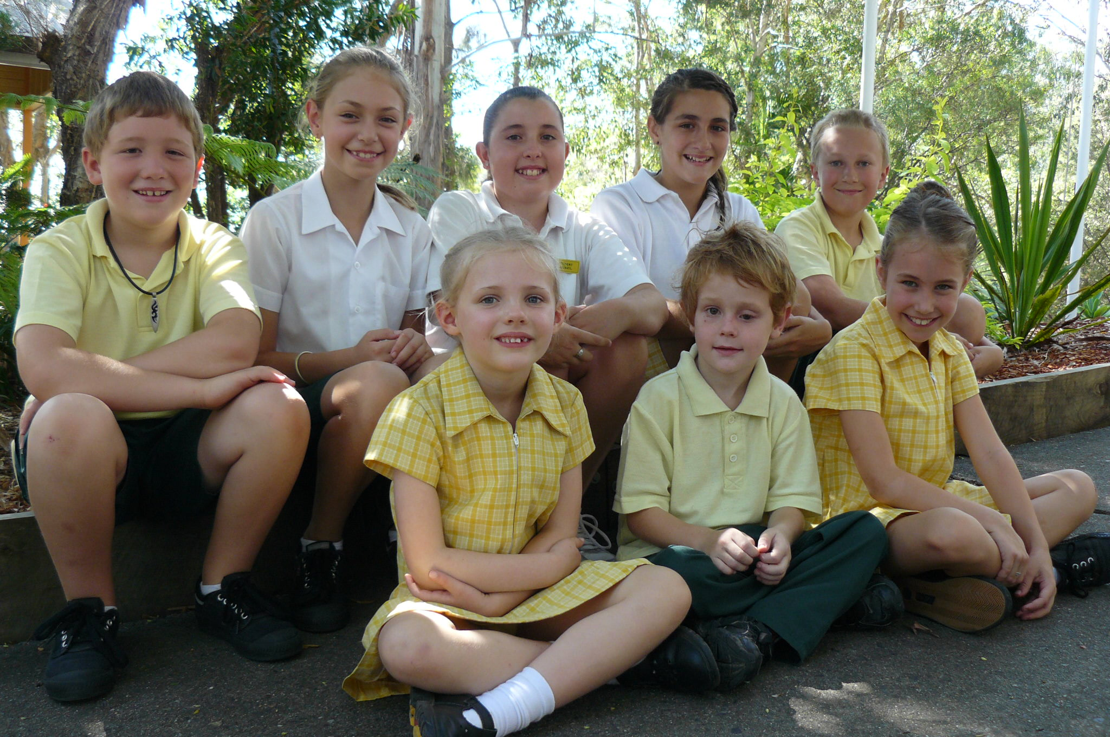

All of our students did an excellent job and we were very proud of them. The day was a wonderful opportunity for all and a great chance for our local Public Schools to extend the rich talent of our debating workshop to be held at our school later in the term.
Congratulations to all students on a wonderful effort.
Danielle Craddock

PRESENTATION DAY
This year our Presentation Day will follow a different format from previous years. Previously it was held of a night time at the high school and only the prize winners and band and choir members attended. This year it will be held of a day time at our own school so that all students will be able to attend. It was also felt that a two hour formal Presentation Evening was a long time for our younger students to sit still.
So that we have enough room for all the students and parents we will be holding it in two sessions. Stage 1 students will be having a combined concert and awards assembly and all parents are invited to this. Stage 2 and 3 will be having the more formal Presentation Day. Because of numbers we are asking that only parents of children receiving awards attend this assembly. All parents will be notified if their child is to receive an award.

PRESENTATION DAY – Wednesday 9th December

Stage 1: 10.00am – 11.00am
A combined concert and awards assembly. All parents are invited.

Stage 2 and 3: 11.45am – 1.15pm
Awards Assembly – Academic, Citizenship and Sports Awards. Parents of students receiving awards will be notified.

For those parents attending both assemblies, morning tea will be available in the COLA.

June O’dell, Deputy Principal

