TOORMINA PUBLIC SCHOOL

N E W S L E T T E R

NEWSLETTER 35/10 – Week 6, Term 4 – 18th November 2010

Dear Toormina Families

MINI FETE
Thank you to our students and their families for the support of our Mini Fete. All reports indicate everyone really enjoyed the day. The P & C are still working out the final expenses before they can telll us how much money was raised.

We have had a phone call today from a parent advising that their child has whooping cough. The NSW Health Department has a website http://www.health.nsw.gov.au/ that has an A – Z of health topics with excellent information about whooping cough.

Our Choir will be singing / busking at the Plaza next Thursday. Please go along and show them your support. Their singing is sure to delight all who hear them!

Elaine Norman
Principal

More important dates for the diary …..

Tuesday 7/12/10
Presentation Day –
Stage 110 am
Stage 2 & 312 pm

Wednesday 8/12/10
OC Orientation

Wednesday 8/12/10
Year 6 Farewell, Sawtell RSL,
6 – 9 pm

Thursday 9/12/10
School Disco

Friday 10/12/10
Year 6 Orientation to Toormina High School

Monday 13/12/10
Stage 3 Pool Day

Tuesday 14/12/10
Carols by Candlelight

Tuesday 14/12/10
Stage 1 Movies

Wednesday 15/12/10
Stage 2 Pool Day



TOORMINA PUBLIC SCHOOL
Truth and Tolerance

ADDRESS:
CAVANBA ROAD,
TOORMINA NSW 2452

TELEPHONE: (02) 6653 2122
FACSIMILE: (02) 6658 2287

EMAIL:
Toormina-p.school@det.nsw.edu.au

WEBSITE:
www.toormina-p.schools.nsw.edu.au

PARENTS & CITIZENS ASSOCIATION

P & C Committee meets
1st Friday of each month
9.15 am in School Staffroom

WHAT’S ON !

- Thursday 25/11/10
Choir Y4 – Y6 to sing at Park Beach Plaza

- Monday 29/11/10
Year 5 / 6 students leave for Canberra –
8 pm

- Monday 29/11/10
Book Fair

- Wednesday 1/12/10
Volunteers Thank you

- Friday 3/12/10
Students return from
Canberra

STUDENT AWARDS:

- Gotcha Being Good – Winners of this week’s “Gotcha Being Good” awards for demonstrating one of our school rules – Be Responsible

Catrina Anderson 4G
Jayden Olive 1P
Kane Boyle 2B
Leilani McConville 3T
Rebecca Tidey KC

CONGRATULATIONS to the above students
(Prizes generously donated by Domino’s Pizza, Eagle Boys Pizza and the School Canteen – Thankyou!)

Club 1000

CONGRATULATIONS to the following achievers:

Katie Shields 3T
Tarrant Munday 1/2H

Club 2000

CONGRATULATIONS to the following achievers:

Pieter Williams 3T
Leilani McConville 3T
Kara Donnan 4G

CHESS NEWS

Billy Ensby, Natalie Hawkins and Mark West have had a great result, placing third in the NSW Junior Chess League - North Coast 3 Person Tournament.

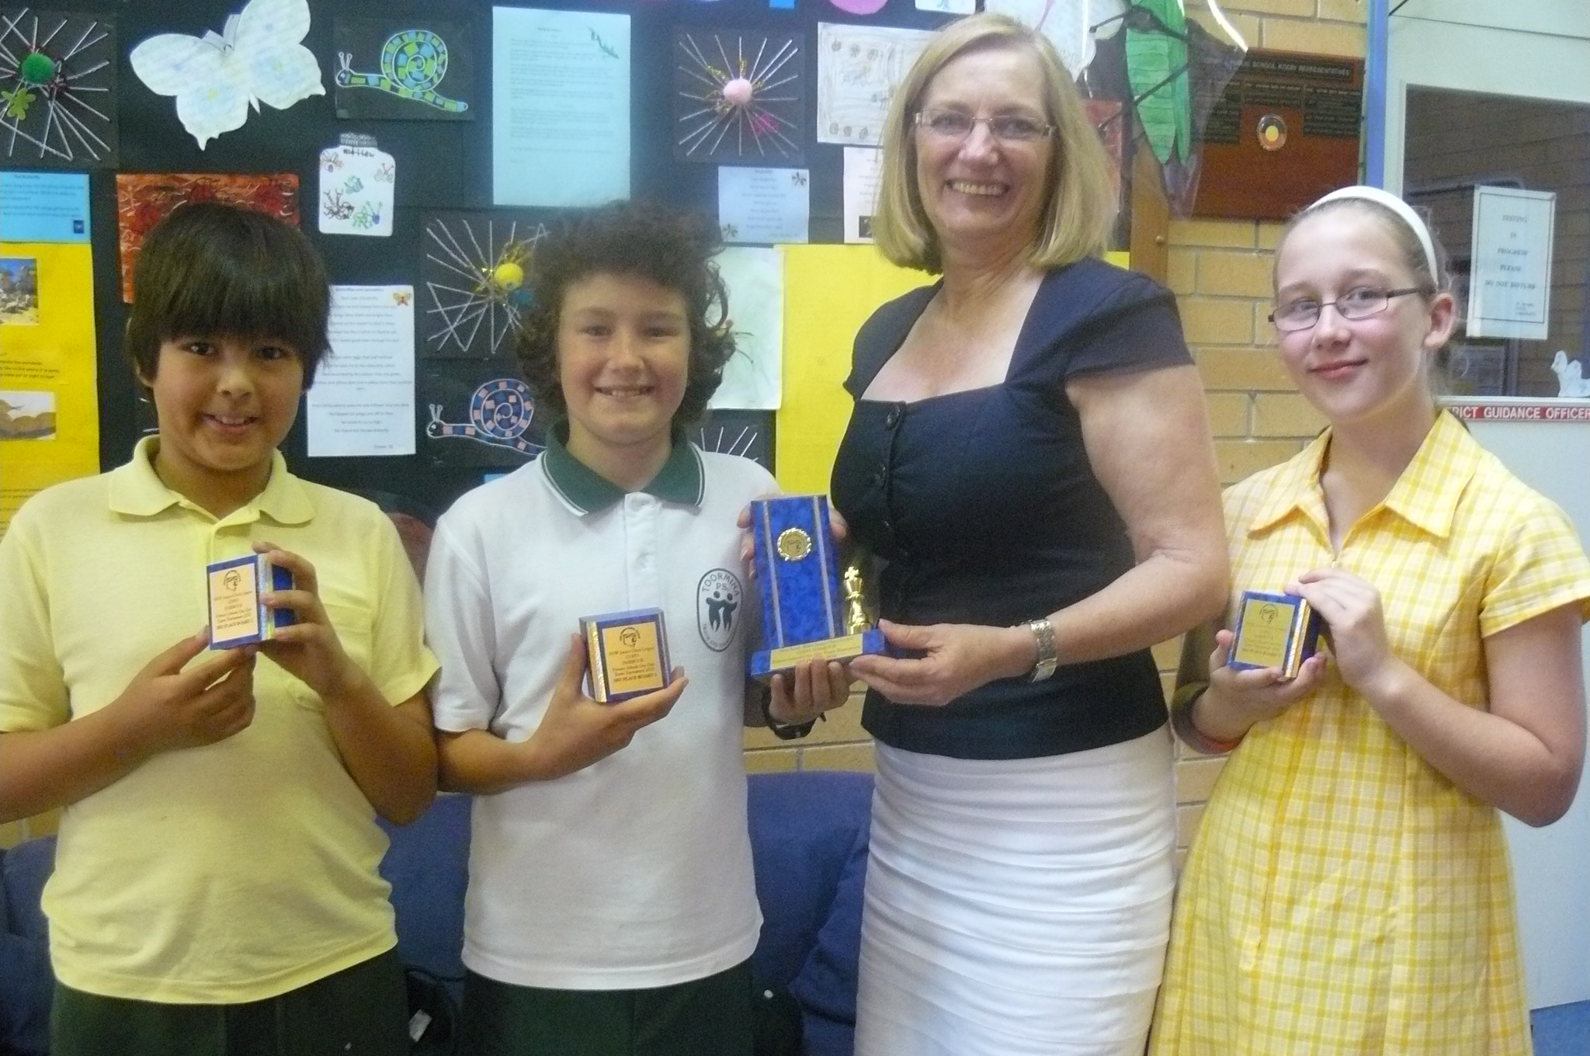

The A Grade team, coached by Mr Gelagin, competed against 13 other teams in their division. They each played 13 games. Billy on Board 1 won ten of his games, Mark on Board 2 won 9 of his games and Natalie on Board 3 won 6 of her games.

Each player had a great day at the competition meeting new and familiar faces among students from Coffs Harbour, Urunga, Bellingen and Nana Glen.

The team acknowledges the strong coaching and support that they have had from Mr Gelagin saying, "We couldn't have done it without him!"

Thanks also goes to Mr West and Mrs Ensby for all of their support and encouragement.

BOOK FAIR
On Monday 29th November we will be holding a book fair in the library. The fair will run from 8:30am – 2:15pm. A percentage of all sales will go to buying new books for the library. There will also be a small selection of preloved books available for purchase.

Parents are invited to come along and have a look, remember books make great Christmas presents!
Rebecca Saunders, Teacher/Librarian

CENTRAL NETWORK DANCE FESTIVAL
This Friday, our Stage 2 and 3 dance groups will be performing at the Central Network Dance Festival to be held at Woolgoolga High School. These students have worked very hard on their performances and we wish them all the best of luck.
Rebecca Saunders & Jenny Kirkland

CAROLS AT THE PLAZA
Fifty students from Years 4, 5 and 6 will be busking, singing Christmas songs, at Park Beach Plaza just prior to the arrival of Santa Claus on the 25th November. This is an exciting opportunity for the performers to raise money for our school with Park Beach Plaza generously offering to double all the money that goes into our hat.

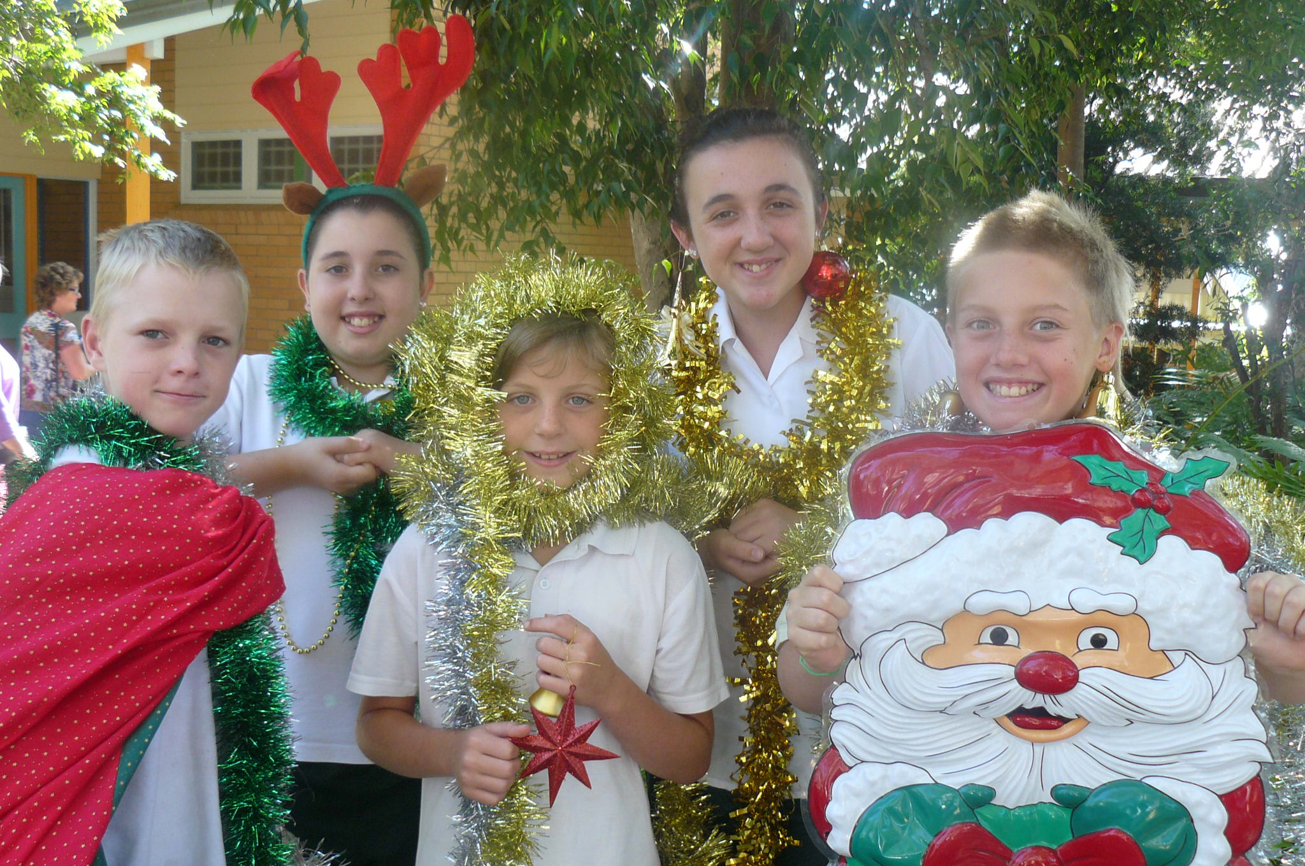

So parents, family and friends please come along to enjoy the student’s performance and bring along some spare change to support their fundraising efforts. They will be singing between 9.30 – 10.00 am at the Promotions Court (where Santa’s throne is normally situated at the Plaza).
Elizabeth Paff, Community Liaison Officer
CHILD PROTECTION LESSONS have commenced at Toormina Public School. An overview of the program is listed below. Parents who would like to know a little more are encouraged to approach either the Principal or Class Teacher.
Week | Title
2 | Recognising Abuse
3 | Body Parts
4 | Feelings and Warning Signals
5 | Identifying Safe and Unsafe Situations
6/7 | Physical Abuse / Sexual Abuse
8 | Effects of Abuse

ATTENTION YEAR 5 & 6 PARENTS
Toormina High School
Year 7
Information Night

Tuesday 23rd November at 6 pm
Toormina High School Library

Principal Mrs Elizabeth Donnan, Head Teacher Welfare Lisa Mullan Year Advisor and members of the transition team will be speaking to parents about the transition from primary school to high school. Representatives from all faculties and Key Learning Areas will be available to answer any questions you may have.

A light supper will be provided.

Any queries about the evening should be directed to Mrs Gaye Devoy or Ms Sue Winsor on
66533 077.

SCHOOL BANKING - Redeeming Tokens

Many students are very close to collecting their 30 tokens for the backpack prize.

A reminder that the tokens are not to be shared or "pooled" between family members or friends. The bank will only issue the backpack prize once their electronic records show that the student has banked on 30 occasions.

Any students who are short of their goal of 30 tokens at the end of this year - don't worry - as the collection of tokens will continue on into next year. So keep on banking!

Steph and Debbie, The Banking Ladies

INTENSIVE SWIMMING SCHEME
Please be reminded that if you wish your child to attend the swimming scheme, note and money must be returned by Wednesday, 24th November.

If your child is in Years 4, 5 or 6 and you would like them to attend, you can obtain a note from Mrs Greenway.
Thanking you, Pam Greenway.

P & C NEWS
Hi everyone,

I hope you all had fun at the fete. It looked like everyone was enjoying themselves from where I was.

A big thank you to all of you, from the donations to the huge support offered on the day, it was wonderful. Thank you!

Only about four weeks of school left and we still have a lot going on.

Firstly, our Christmas Hamper Raffle. Please could donations of non-perishable goods be sent in to school now e.g. canned foods, packet foods, drinks, lollies, chips, Christmas decorations, etc. Please, if you are raiding your pantry check expiry dates. I will organise raffle books to hopefully be sent home next week sometime.

We are going to hold a Christmas Stall this year, with some lovely gifts ranging in price from $2 - $10. More on this when a date has been set.

School Disco is on the 9th December. This will be an evening one with a DJ.

Christmas Carols. We will be holding Carols by Candlelight at school this year. This will be on 14th December. This should be a great family night and we hope to see the whole school there with all their friends and family sharing in a special night.

We have some battery operated candles which will look great on the night and at home without the danger of fire. We will also be holding a BBQ as well as selling chips, lollies, etc. This should be a good night and hopefully a tradition will be started! More about the Carols next week.

Don’t forget donations for the Christmas Hamper, right away (time is running away from us). Whatever you can do will be greatly appreciated. I know once again, you will all do your best!
Thank you, Angela.



JOKE CORNER

The more you take away the bigger it gets – what is it?
A hole!
What has three eyes and one leg?
A traffic light?
What goes round the world but stays in one corner?
A postage stamp!
Why did the cow cross the road?
To go to the moo-vies?
Why did the boy throw the butter at the fly?
To see the butterfly!

CANTEEN ROSTER

Friday 19.11.10 April Ingram, Jeanenne Shipman, Helen Ingram
Monday 22.11.10 Tania Tate, Fiona Fox
Tuesday 23.11.10 Taquita Garic
Wednesday 24.11.10 Kristal McIntosh, Stuart Darcy
Thursday 25.11.10 Toni Montgomerie



One to one tuition that builds on student strengths and weaknesses and promotes self-confidence in an encouraging and motivating environment.

“I assist students to reach their full potential”

Private Tuition K-6

Fully Qualified Primary School Teacher
Tuition in all areas of Maths and English, Homework and Project assistance.

Affordable rates. Mon—Fri

Contact Julie Kirkman 66585565 or 0431318683

MINI FETE

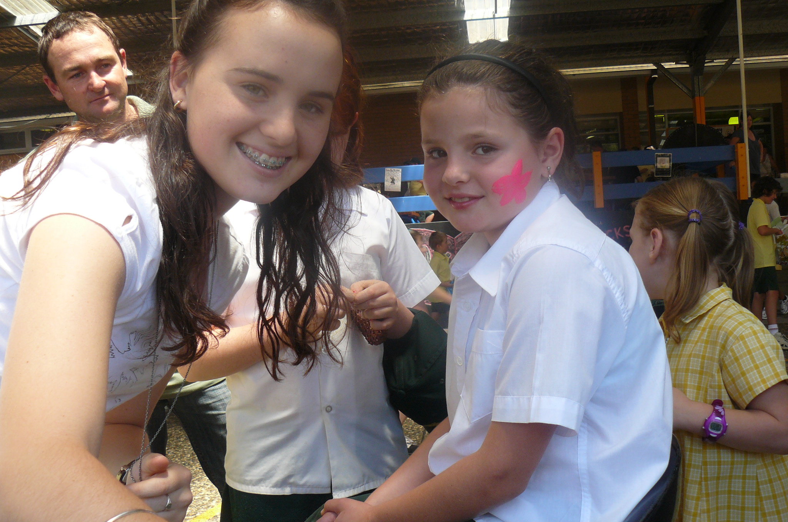

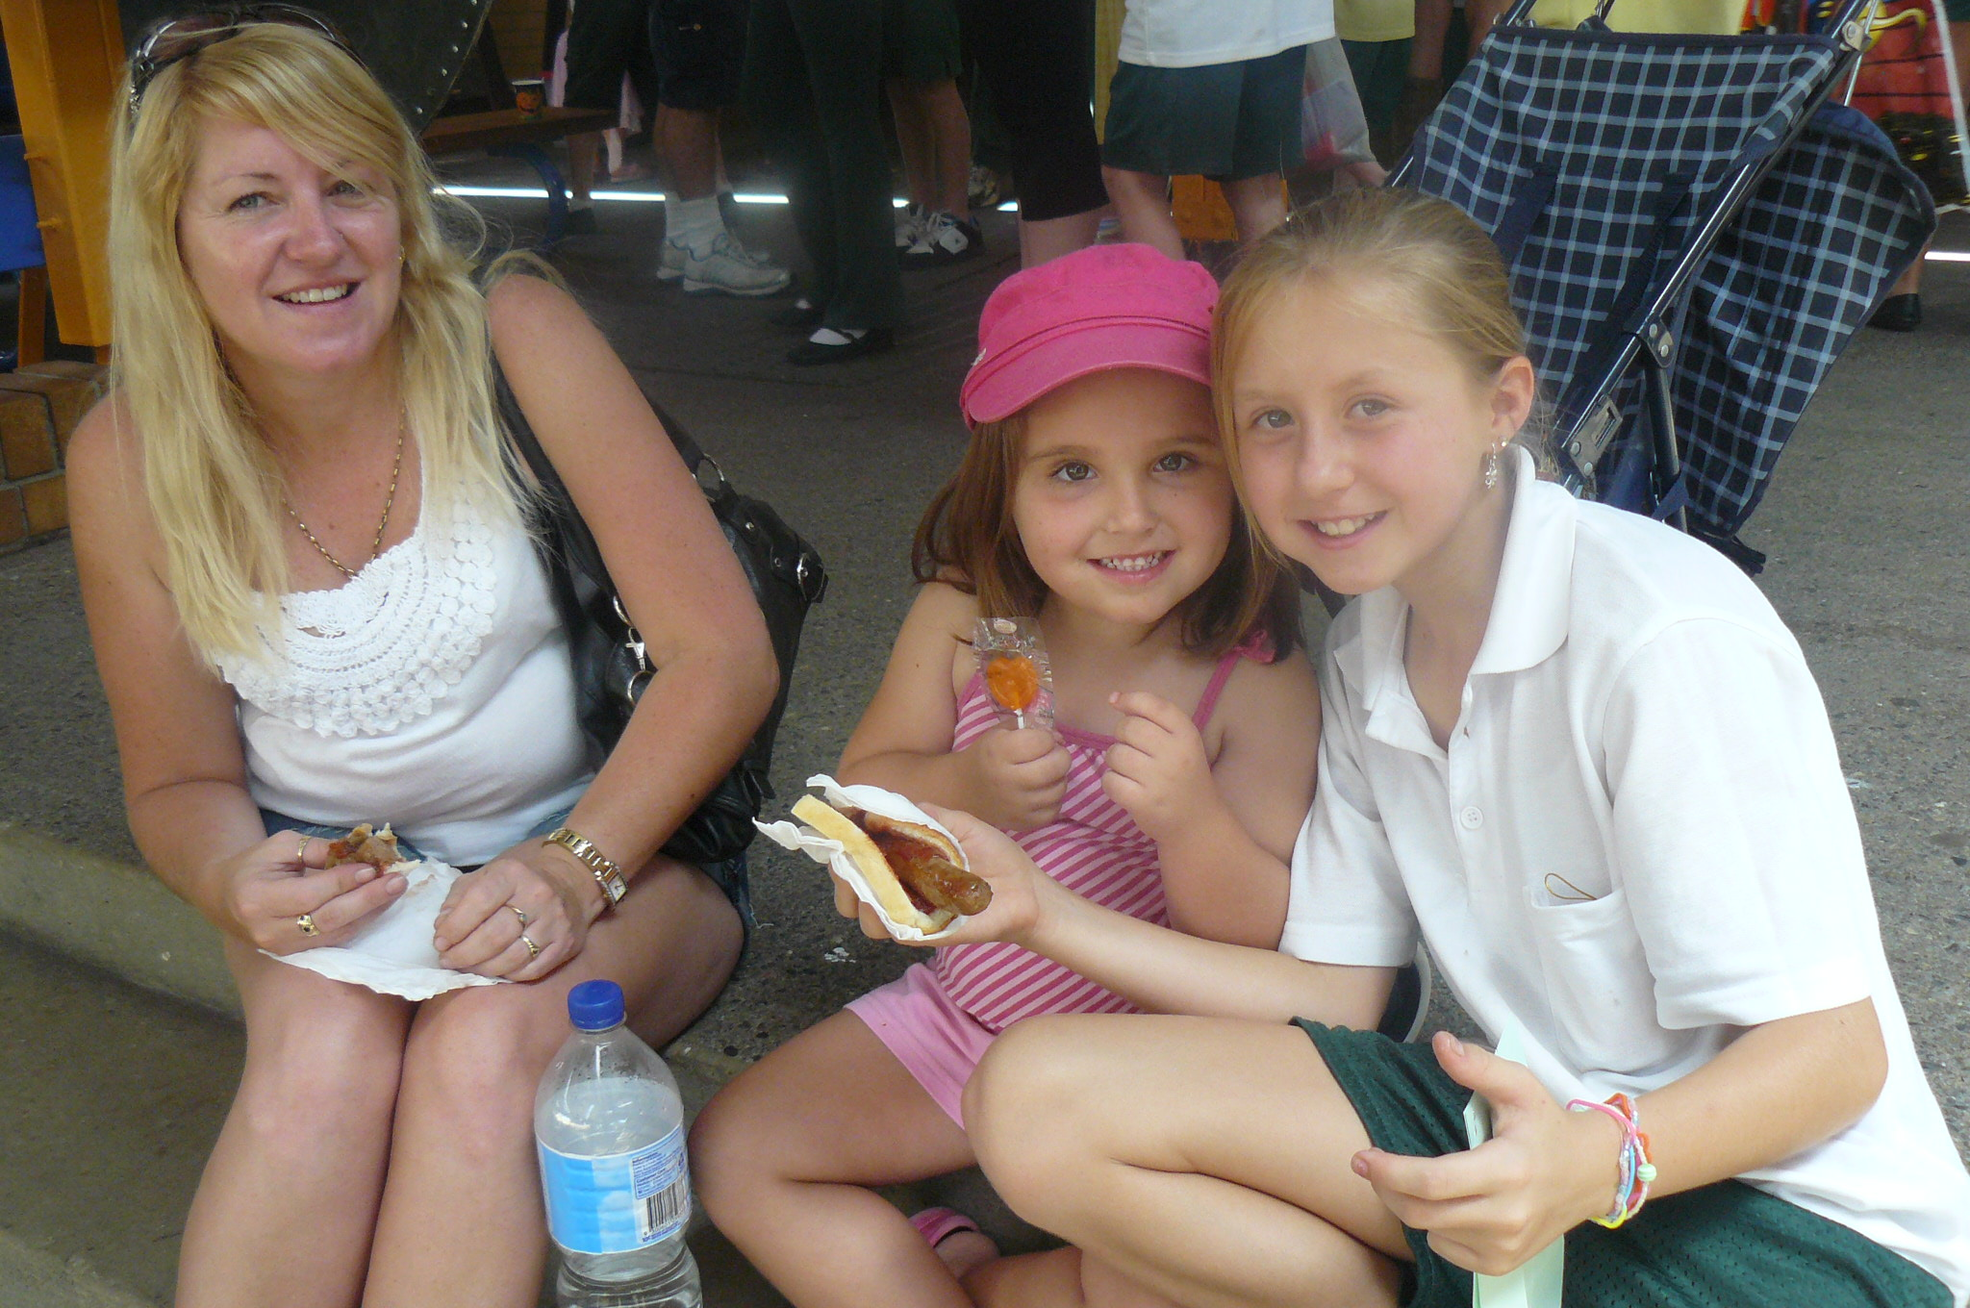
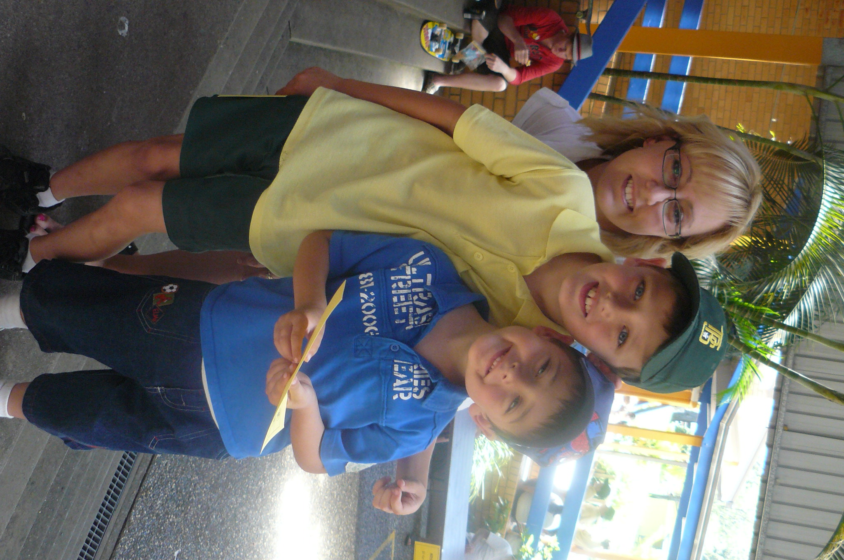

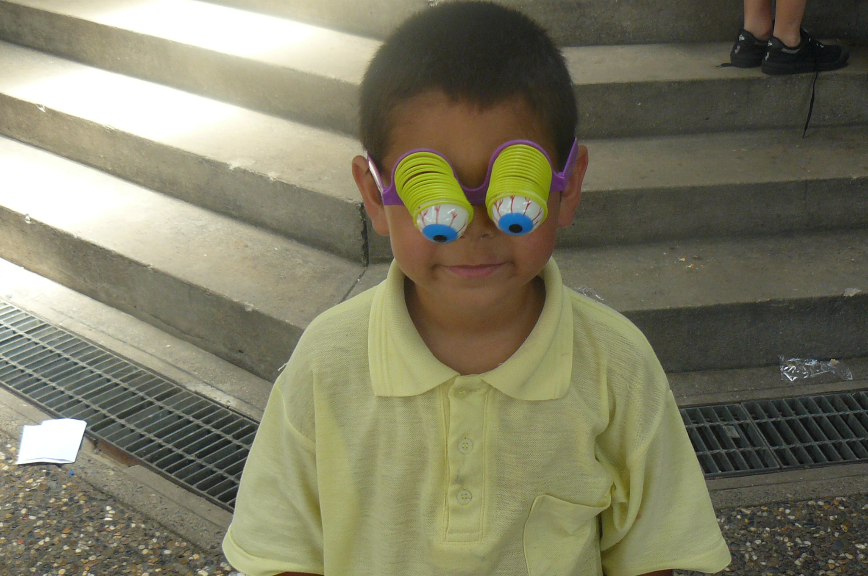

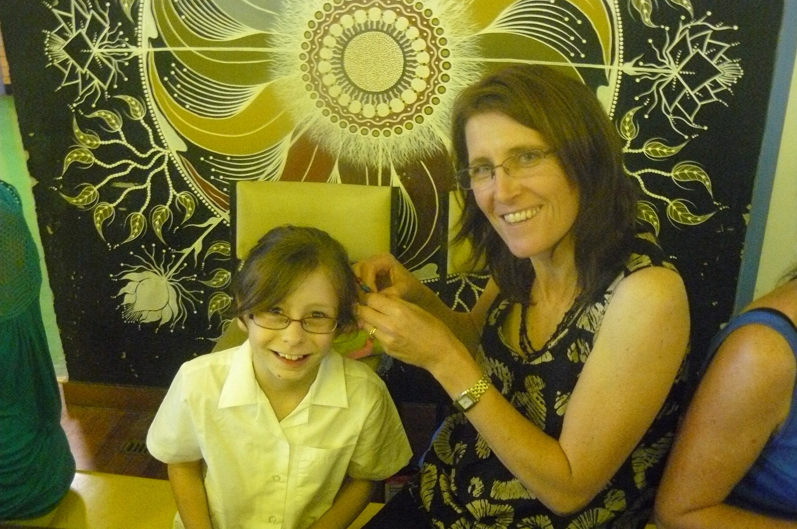
Private Tuition K-6

Fully Qualified Primary School Teacher
Tuition in all areas of Maths and English, Homework and Project assistance.
#

RIPCURL GIRLS
GO SURFING DAY

A Global Learn to Surf Program

COFFS HARBOUR
Saturday 27th and Sunday 28th November
SAWTELL
Sunday 28th November

All equipment is supplied and a gift pack
for all participants
Bookings essential

Lee Winkler’s Surf School
66 500 0050

Welcome
new residents
to the Coffs Coast!
If you are new to the Coffs Coast,
don’t miss out on the fun and BBQ on
Saturday 20 November at
the Pet Porpoise Pool from 12.30pm.

• Receive free seal kisses and be ‘touched by
magic’ at the Marine Show
• Enjoy a BBQ lunch, face painting and official
welcome from Mayor Keith Rhoades
• Experience a scenic walk by the Coffs
Ambassadors at 3pm (limited places call
6648 4676).

Cost: $15 Adults, $11 for pensioners and students, $7.50 for children and $40 for a family pass (2 adults and 2 children).
To book, call the Pet Porpoise Pool on
6659 1900.

FREE FAMILY EVENT

Christmas Decoration Craft
Make decorations
to keep or to give to friends
Saturday 11th December 2010
Coffs harbout City Library
Anytime between 10 am and 12 noon
No need to book
Entry by gold coin donation please
For more information phone
Judy on 6648 4905
www.coffsharbout.nsw.gov.au/citylibrary

Norco
Community
Cash Caps

Remember to send in your milk lids
with your child’s class and number
on the lid for a chance
to win a prize

CHRISTMAS FAMILY NIGHT

Bunnings Coffs Harbour
Thursday 2nd December 2010
6 – 8 pm

Come join in the fun
ITS FREE

Jumping castles, Lucky Door Prizes,
Santa Visit
Old Macdonalds Farm
Face Painting
Sausage Sizzle (Titivators for Breast Cancer)
Childrens DIY – Christmas Crafts

To register – contact 6650 7600
Or in store at the Service Desk



Sawtell Uniting Church
and
Sawtell Golf Club Ltd
invite you to attend

SAWTELL CAROLS BY CANDLELIGHT
Monday, 20th December 2010

Join us on the 9th fairway of the
Sawtell Golf club from 6pm
Bring a blanket and a picnic dinner or there will be food and refreshments available
from the club
Jumping castle and activities for the kids
Santa will be arriving at 7.30pm to start t

