TOORMINA PUBLIC SCHOOL

N E W S L E T T E R

NEWSLETTER 36/10 – Week 7, Term 4 – 25th November 2010

Dear Toormina Families

Last Friday evening I had the pleasure of watching our Stage 2 and Stage 3 dance groups perform at the Central Network Regional Dance Festival. It was a wonderful celebration of the talents of teachers and students in public schools from Grafton to Macksville.

It was great to experience the childrens’ excitement and enthusiasm in performing in front of such a large audience. Congratulations to our wonderful student dancers, and a big thank you for Mrs Saunders and Mrs Kirkland for their dedication and commitment to the children of Toormina Public School.

This morning the Stage 3 Choir performed at the Plaza presenting a repertoire of three Christmas Carols to a large audience of parents, family, friends and shoppers.

The children’s singing brought everyone to a standstill and gave us all ‘goosebumps’. We are all now looking forward to their performance at our ‘Carols by Candlelight’ evening. Special congratulations to Amie Baxter, Amber Grierson, Amelia Elzer, Ksena Griffiths, Keiran Lopes on their ‘solo moments’.

The children’s singing raised $274 in donations from the audience and a $500 donation from the Plaza. These funds will be placed in the music budget for 2011.

Our choir is led and trained by our specialist music teacher, Mrs Jenny Colvin who is accompanied by Sandra Lawrence.

Congratulations to Amber Grierson on her participation in the North Coast Representative Debating at the State level.

Great news!! From today our children will be able to use the new basketball court. The covered walkway is a couple of weeks away from completion. It is an amazing structure that the children will make great use of.

Elaine Norman
Principal



TOORMINA PUBLIC SCHOOL
Truth and Tolerance

ADDRESS:
CAVANBA ROAD,
TOORMINA NSW 2452

TELEPHONE: (02) 6653 2122
FACSIMILE: (02) 6658 2287

EMAIL:
Toormina-p.school@det.nsw.edu.au

WEBSITE:
www.toormina-p.schools.nsw.edu.au

PARENTS & CITIZENS ASSOCIATION

P & C Committee meets
1st Friday of each month
9.15 am in School Staffroom

WHAT’S ON !

- Monday 29/11/10
5/6C excursion to Luke Hartsuyker’s Office

- Monday 29/11/10
Year 5 / 6 students leave for Canberra –
8 pm

- Monday 29/11/10
Book Fair

- Wednesday 1/12/10
Volunteers Thank you

- Friday 3/12/10
Students return from
Canberra

STUDENT AWARDS:

- Gotcha Being Good – Winners of this week’s “Gotcha Being Good” awards for demonstrating one of our school rules – Be Responsible

Clinton Garic 5/6N
Jacob Chuidian 1P
Darlene Barwise 3KC
Bayne Shipman 3KC
Declan Bannerman 1L

CONGRATULATIONS to the above students
(Prizes generously donated by Domino’s Pizza, Eagle Boys Pizza and the School Canteen – Thankyou!)

Club 1000

CONGRATULATIONS to the following achievers:

Gwillum Jones 1L
Ashleigh Clark KC

Club 2000

CONGRATULATIONS to the following achievers:

Matthew Donnan 2B

BOOK FAIR
On Monday 29th November we will be holding a book fair in the library. The fair will run from 8:30am – 2:15pm. A percentage of all sales will go to buying new books for the library. There will also be a small selection of preloved books available for purchase.

Parents are invited to come along and have a look, remember books make great Christmas presents!
Rebecca Saunders, Teacher/Librarian



AFTERNOON TEA

Toormina Public School
would like to thank the many parents
and community members
who kindly support our school
in so many ways

You are cordially invited to attend
Afternoon Tea
to be held in the school staffroom
on
Wednesday 1st December 2010
at 2.00 pm

We hope you will be able to join us on the day and enable us to thank you for your help throughout the year
CHILD PROTECTION LESSONS have commenced at Toormina Public School. An overview of the program is listed below. Parents who would like to know a little more are encouraged to approach either the Principal or Class Teacher.
Week | Title
2 | Recognising Abuse
3 | Body Parts
4 | Feelings and Warning Signals
5 | Identifying Safe and Unsafe Situations
6/7 | Physical Abuse / Sexual Abuse
8 | Effects of Abuse

NORCO BOTTLE CAPS CAMPAIGN

A huge thank you to all the families
who have supported this fundraiser.

Our school has raised $810 this year.
This money goes to our SRC who will decide how it can best benefit our school.
So keep collecting those caps.
Each Norco milk cap = 10 cents for our school.

Children simply write their class and number (given by class teacher) onto caps with permanent marker. Caps go into a weekly draw to win a free pizza meal – thanks to our supporters:
Eagle Boys Pizza and
Dominoes Pizza (Toormina)

SCHOOL BANKING - Redeeming Tokens

Many students are very close to collecting their 30 tokens for the backpack prize. A reminder that the tokens are not to be shared or "pooled" between family members or friends. The bank will only issue the backpack prize once their electronic records show that the student has banked on 30 occasions.

Any students who are short of their goal of 30 tokens at the end of this year - don't worry - as the collection of tokens will continue on into next year. So keep on banking!
Steph and Debbie, The Banking Ladies

WHOOPING COUGH (Pertussis)
Whooping cough is a serious infection that causes a long coughing illness. Whooping cough starts like a cold with a blocked or runny nose, sneezing, a mild fever and an occasional cough. A person with whooping cough can spread it to others in the first three weeks of the illness. Adults and children can get whooping cough and can spread the infection to babies. Vaccines are available from your GP. Brochures are available from the school office or visit the NSW Health site at: www.health.nsw.gov.au/publichealth/immunisation/index.asp
ICE-CREAM DAY FOR DEBATING

Thank you to everyone who recently bought ice-creams in support of Amber Grierson who is part of the North Coast Debating team. We served over 250 ice-creams with sprinkles and lollies. It was a great day.

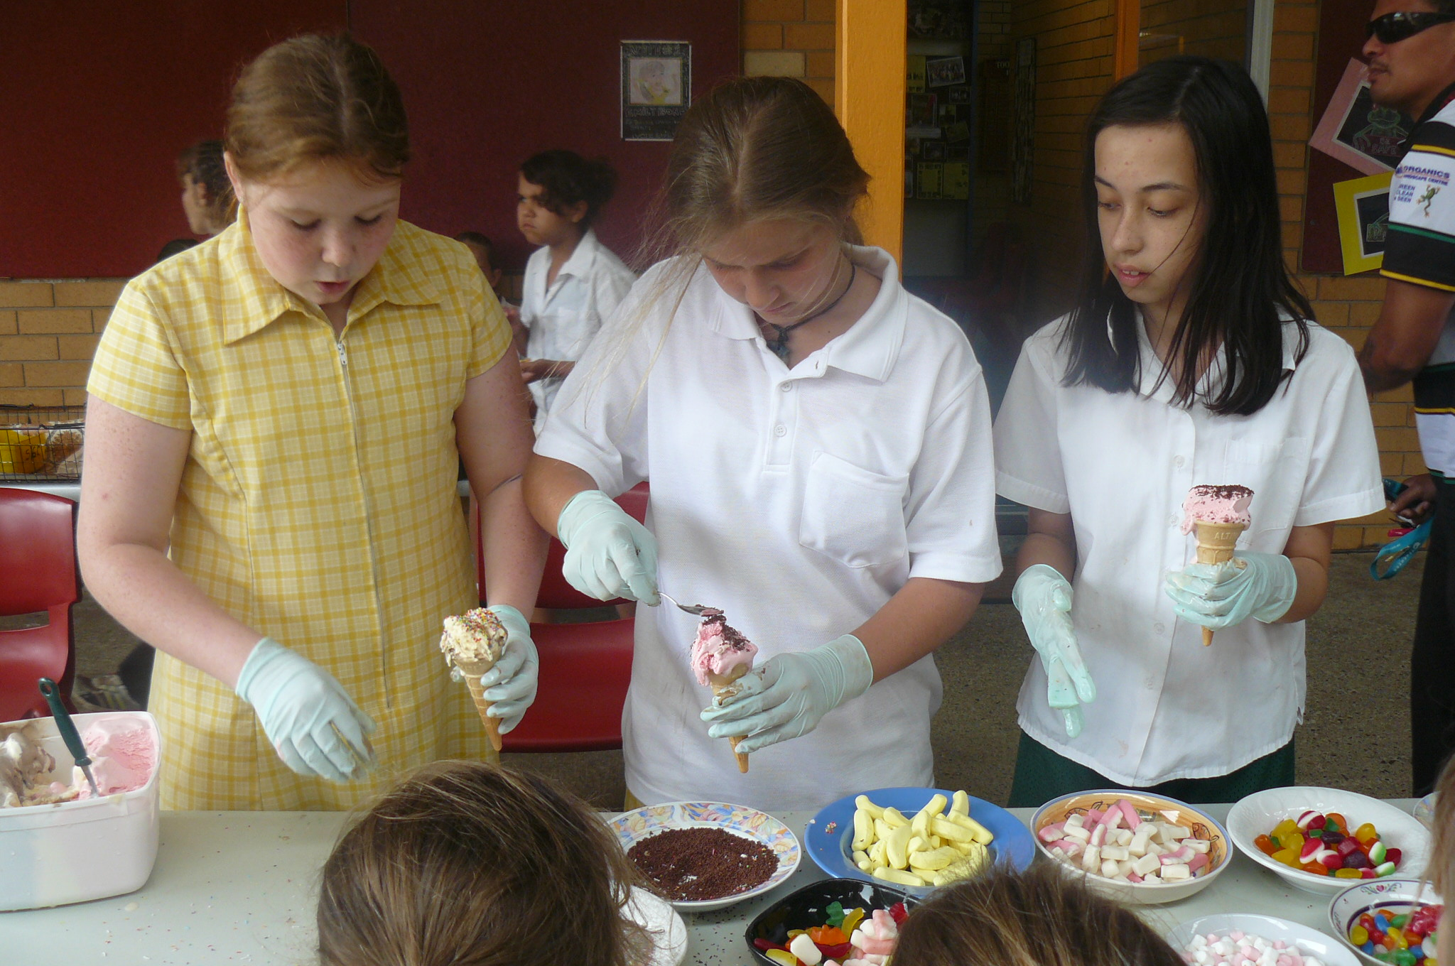
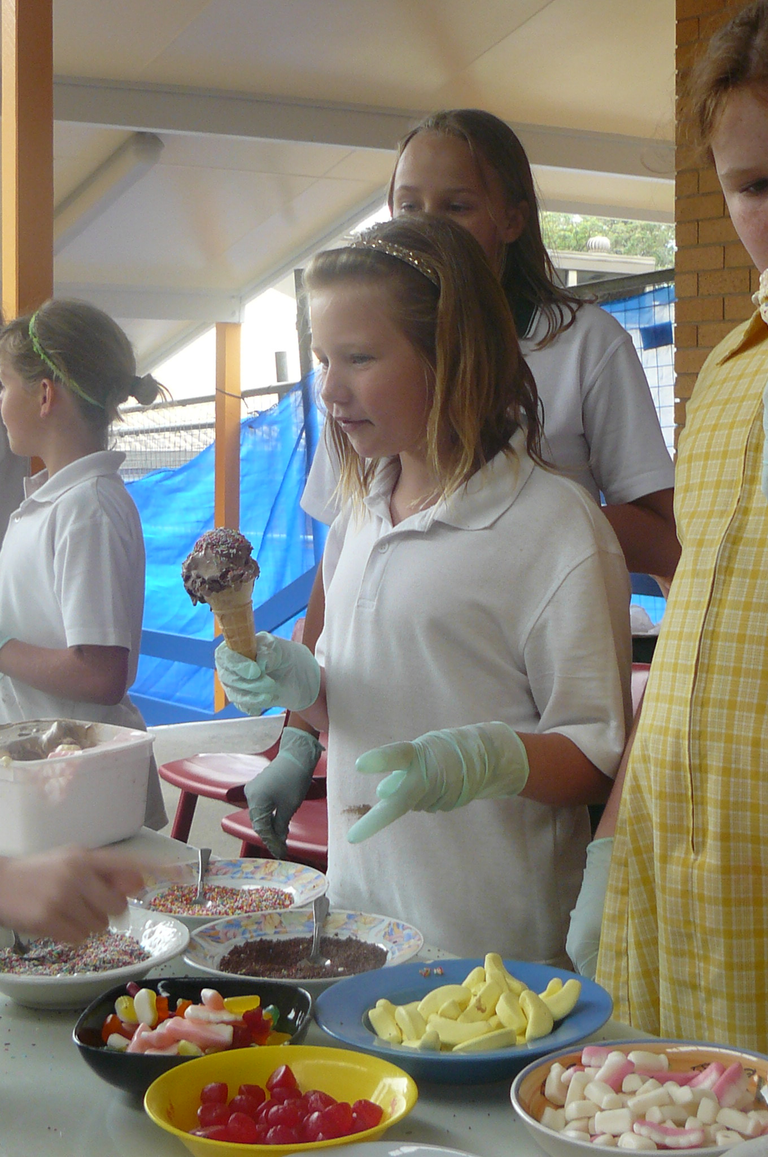
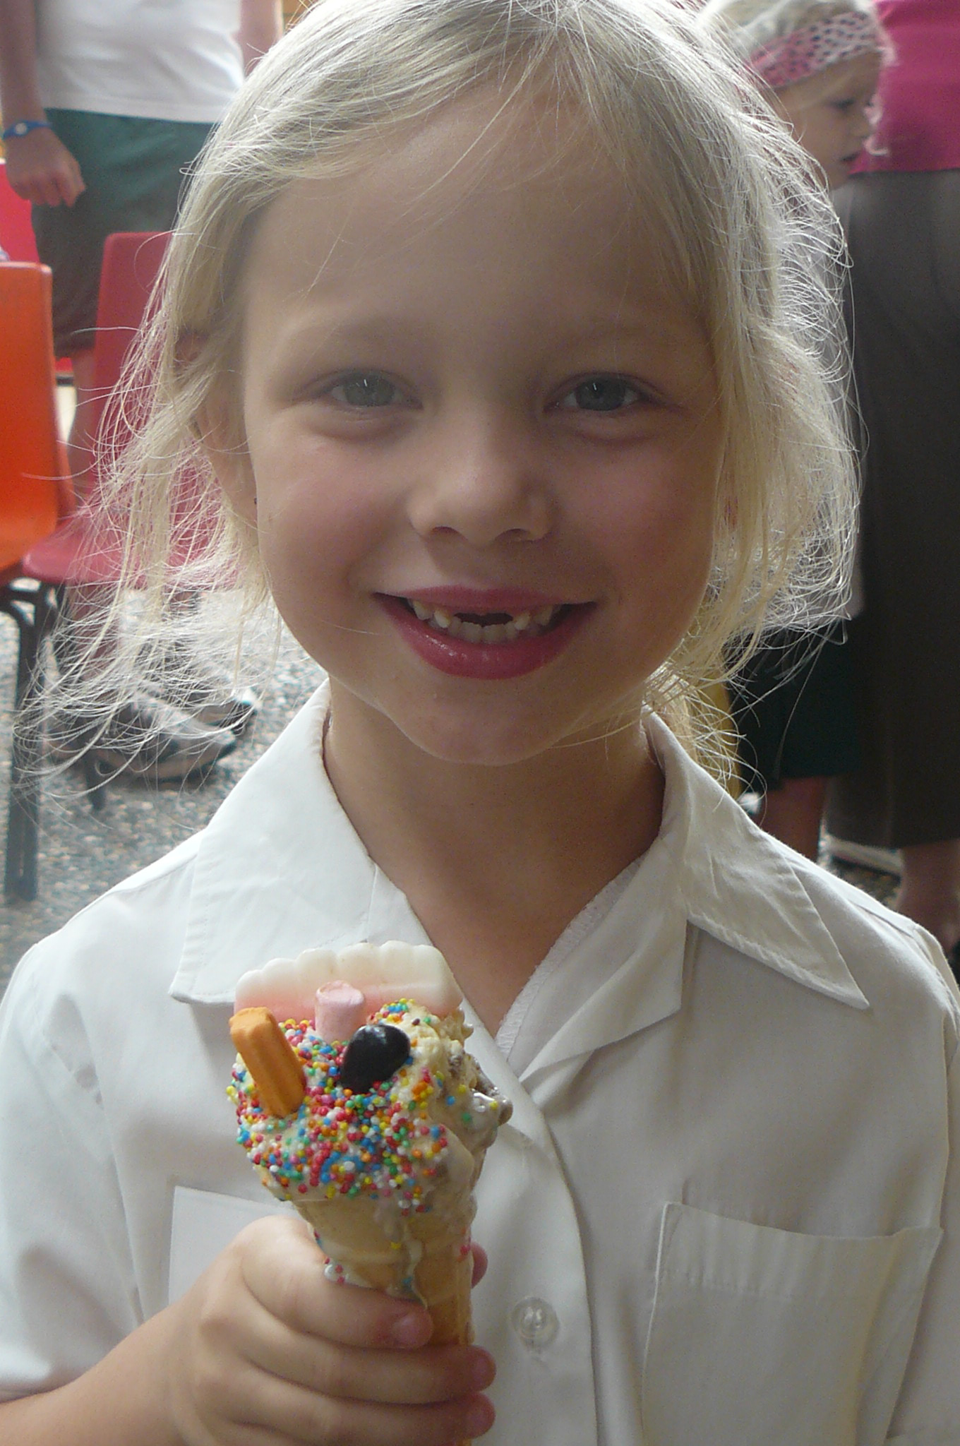

Amber travelled to Sydney on Sunday afternoon and arrived back home Wednesday. Her team competed in five debates and got into the semi-finals before just being beaten by Illawarra. We are very proud of Amber and her representation of our school.

Also a special thanks to Derek Beverley at Crazy Clarks Toormina who donated all of the lollies for our day.

Danielle Craddock
Class Teacher



JOKE CORNER

What bow can’t be tied?
A rainbow!
Which famous film cartoon-maker spun around in circles?
Walt Dizzy?
What do you call a billabong in wintertime?
A chillabong!
Where do great Australians wash their faces?
The Great Australian Basin?
Why do bees have sticky hair?
Because they use honeycomb!

CANTEEN ROSTER

Friday 26.11.10 April Ingram, Jeanenne Shipman, Helen Ingram
Monday 29.11.10 Tania Tate
Tuesday 30.11.10 Katrina Winkler, Taquita Garic
Wednesday 1.12.10 Kristal McIntosh
Thursday 2.12.10 Toni Montgomerie

Penny Szafranski, Canteen Supervisor

P & C NEWS
Hi everyone,
Firstly we really need donations for the Christmas Hamper raffle now! Donations of non-perishable goods e.g. tin or packet foods, chips, chocolates, biscuits, etc would be appreciated. Please check the expiry dates! This raffle will be drawn at our Christmas Carols.

Christmas Carols will be held at our school for the first time this year. They will be held on the 14th December commencing at 6 pm. Please fill in the tear-off slip below and return to class teacher as soon as possible so we have some idea of numbers for catering purposes as the P & C will be holding a barbecue.

Disco – last one for the year and the biggest with a DJ will be held on the 9th December in the evening. The cost of this will be $3.00 to cover the cost of the DJ.

We will also set up the Christmas Stall on the night so parents, as well as children will have the opportunity to buy some lovely gifts ranging in price from $2.00 - $10.00. We will also set up the Christmas Stall at the Carols.

Times for the Disco are:

- Stage 1 - 5.30 pm – 6.45 pm
- Stage 2 and 3 - 7.00 pm – 9.00 pm

Christmas Carols
Please complete the tear-off slip below and return to class teacher as soon as you can. We need an idea of numbers for catering purposes.

I hope everyone comes along for this special evening, with excitement building and plans well lunder way, we hope this will become a tradition here at Toormina.

I almost forgot to thank you for your support of the fete and let you know that the fete took a healthy $4,000. We estimate that we have cleared $3,000. Good going guys. This, along with what was made at the Trivia night brings us about half way toward the purchase of the A3 scanner and photocopier we are aiming for.

Raffle tickets for the Christmas Hamper will be sent home early next week.
Thanks, Angela.

------------------------------------------------------------

CHRISTMAS CAROLS
14th December, 6 pm in the School COLA

Child’s Name: __________________________

Child’s Class: ___________________________

Number of people attending: _______________

Everyone welcome – parents, grandparents, friends, etc.

Please return this slip to class teacher



One to one tuition that builds on student strengths and weaknesses and promotes self-confidence in an encouraging and motivating environment.

“I assist students to reach their full potential”

Private Tuition K-6

Fully Qualified Primary School Teacher
Tuition in all areas of Maths and English, Homework and Project assistance.

Affordable rates. Mon—Fri

Contact Julie Kirkman 66585565 or 0431318683

RIPCURL GIRLS
GO SURFING DAY

A Global Learn to Surf Program

COFFS HARBOUR
Saturday 27th and Sunday 28th November
SAWTELL
Sunday 28th November

All equipment is supplied and a gift pack
for all participants
Bookings essential

Lee Winkler’s Surf School
66 500 0050

FREE FAMILY EVENT
Christmas Decoration Craft
Make decorations
to keep or to give to friends
Saturday 11th December 2010
Coffs harbout City Library
Anytime between 10 am and 12 noon
No need to book
Entry by gold coin donation please
For more information phone
Judy on 6648 4905
www.coffsharbout.nsw.gov.au/citylibrary

CHRISTMAS FAMILY NIGHT

Bunnings Coffs Harbour
Thursday 2nd December 2010
6 – 8 pm

Come join in the fun
ITS FREE

Jumping castles, Lucky Door Prizes,
Santa Visit
Old Macdonalds Farm
Face Painting
Sausage Sizzle (Titivators for Breast Cancer)
Childrens DIY – Christmas Crafts

To register – contact 6650 7600
Or in store at the Service Desk



Sawtell Uniting Church
and
Sawtell Golf Club Ltd
invite you to attend

SAWTELL CAROLS BY CANDLELIGHT
Monday, 20th December 2010

Join us on the 9th fairway of the
Sawtell Golf club from 6pm
Bring a blanket and a picnic dinner or there will be food and refreshments available
from the club
Jumping castle and activities for the kids
Santa will be arriving at 7.30pm to start the Carols

DATES FOR THE DIARY ….

As the end of term draws to a close we have drawn up a calendar of events for your information:

- Monday 29/11/10 5/6C excursion to Luke Hartsuyker’s Office

- Monday 29/11/10 Year 5 / 6 students leave for Canberra – 8 pm

- Monday 29/11/10 Book Fair

- Wednesday 1/12/10 Volunteers Thank you – 2 pm

- Friday 3/12/10 Students return from Canberra

- Tuesday 7/12/10 Presentation Day:
Stage 1 10 am
Stage 2 & 3 12 pm

- Wednesday 8/12/10 OC Orientation

- Wednesday 8/12/10 Year 6 Farewell, Sawtell RSL, 6 – 9 pm

- Thursday 9/12/10 School Disco:
Stage 1 5.30 pm – 6.45 pm
Stage 2 & 3 7.00 pm – 9.00 pm

- Friday 10/12/10 Year 6 Orientation to Toormina High School

- Monday 13/12/10 Stage 3 Pool Day

- Tuesday 14/12/10 Carols by Candlelight, 6 pm

- Tuesday 14/12/10 Stage 1 Movies

- Wednesday 15/12/10 Stage 2 Pool Day

- Wednesday 15/12/10 Last day of school for students

FESTIVAL OF DANCE
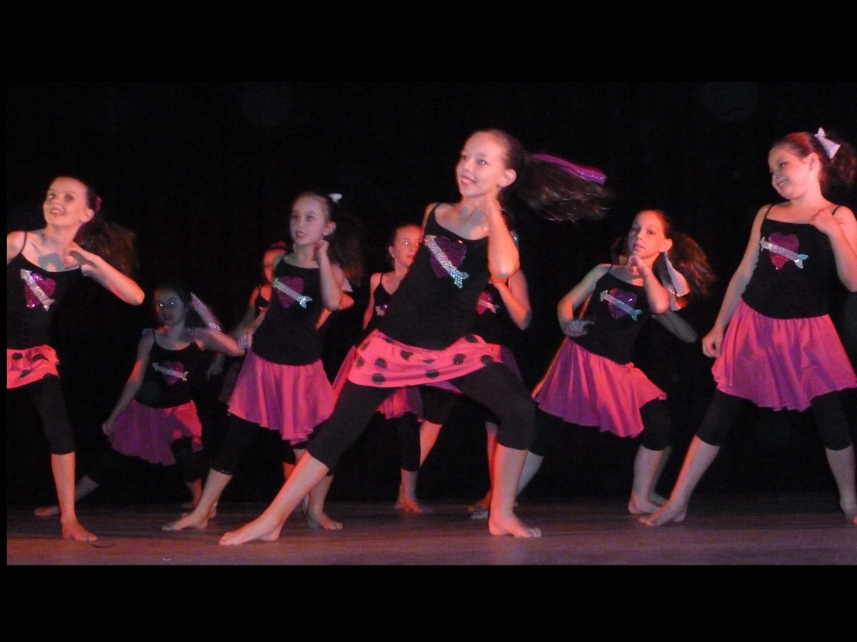
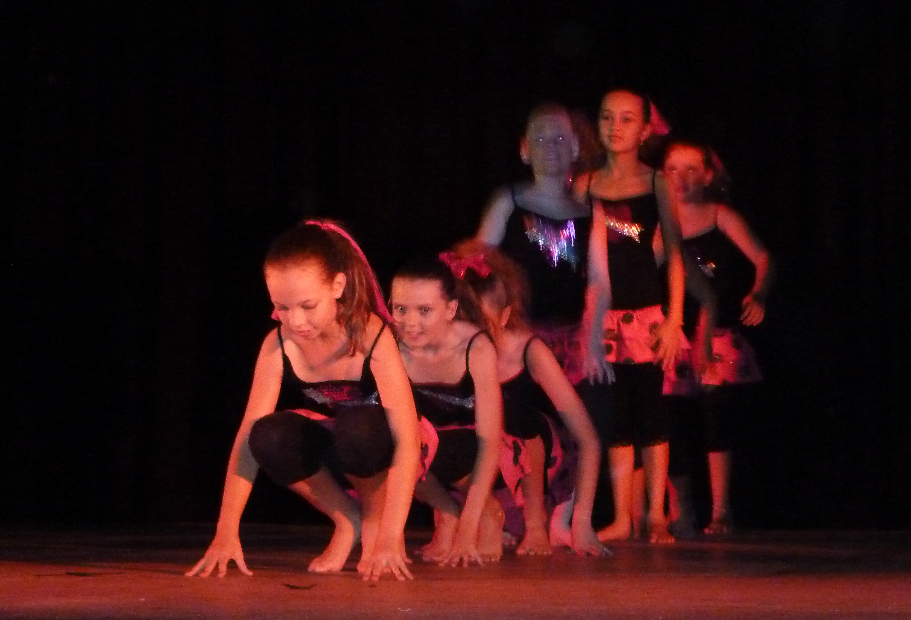

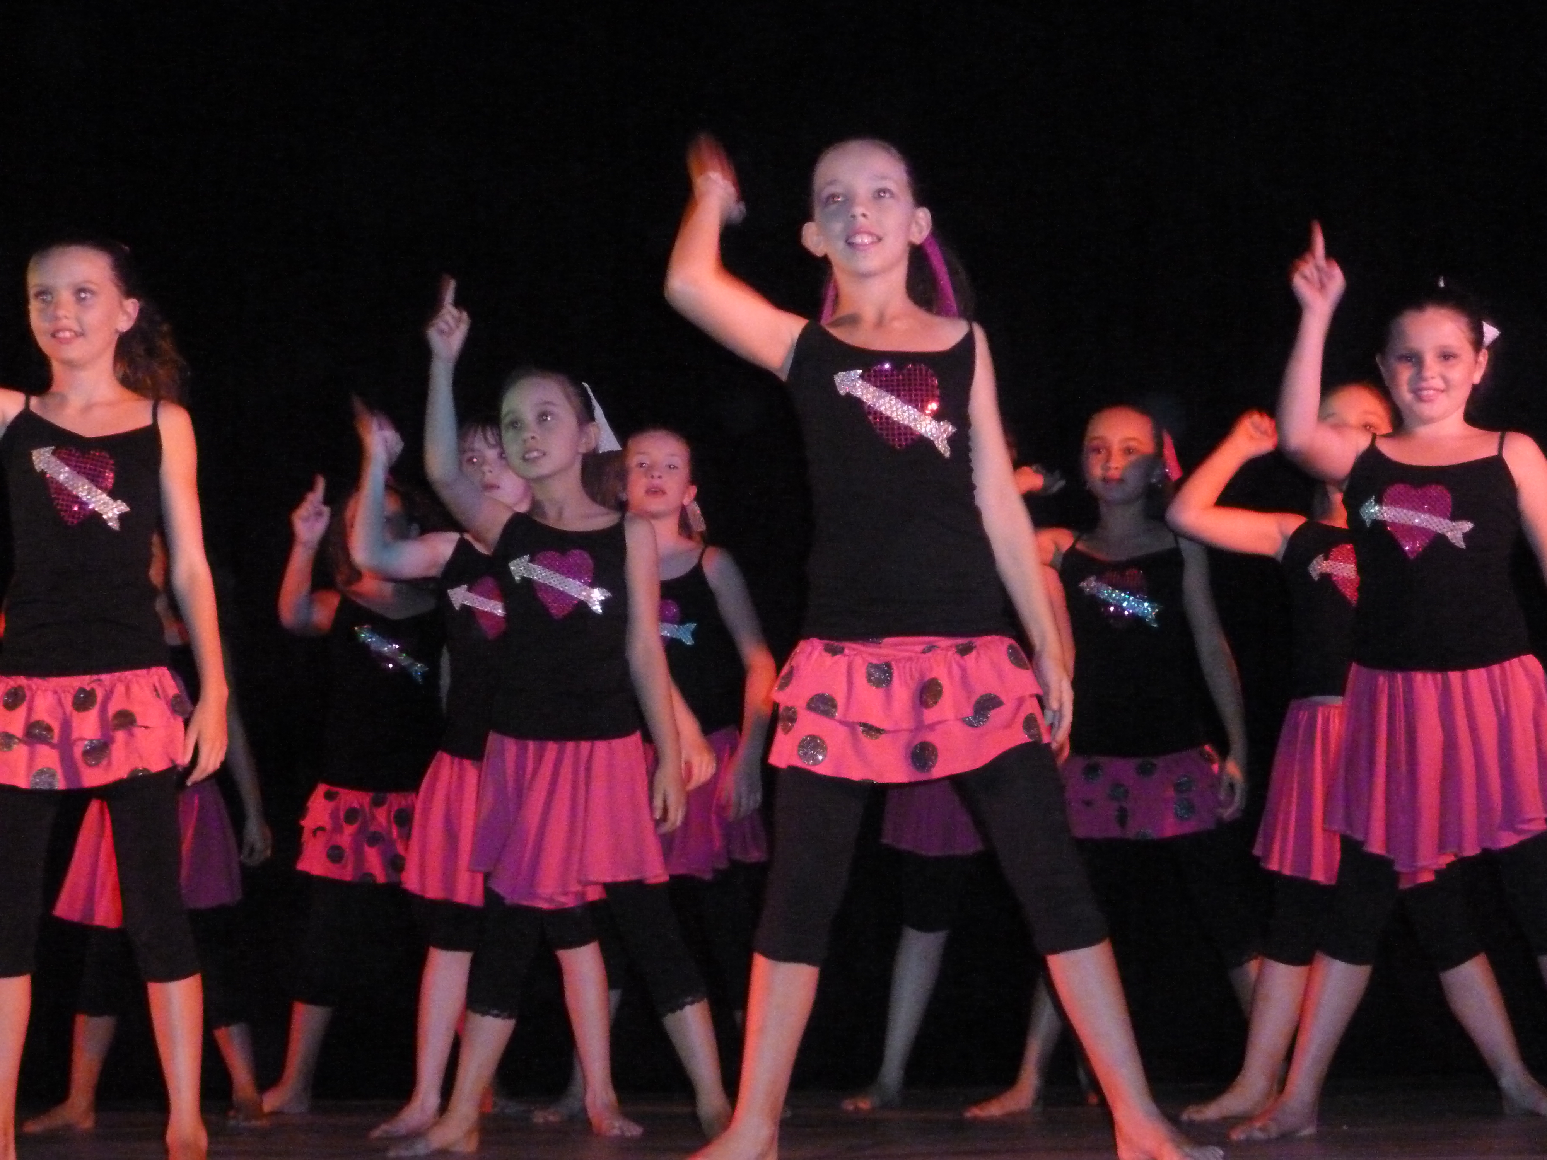

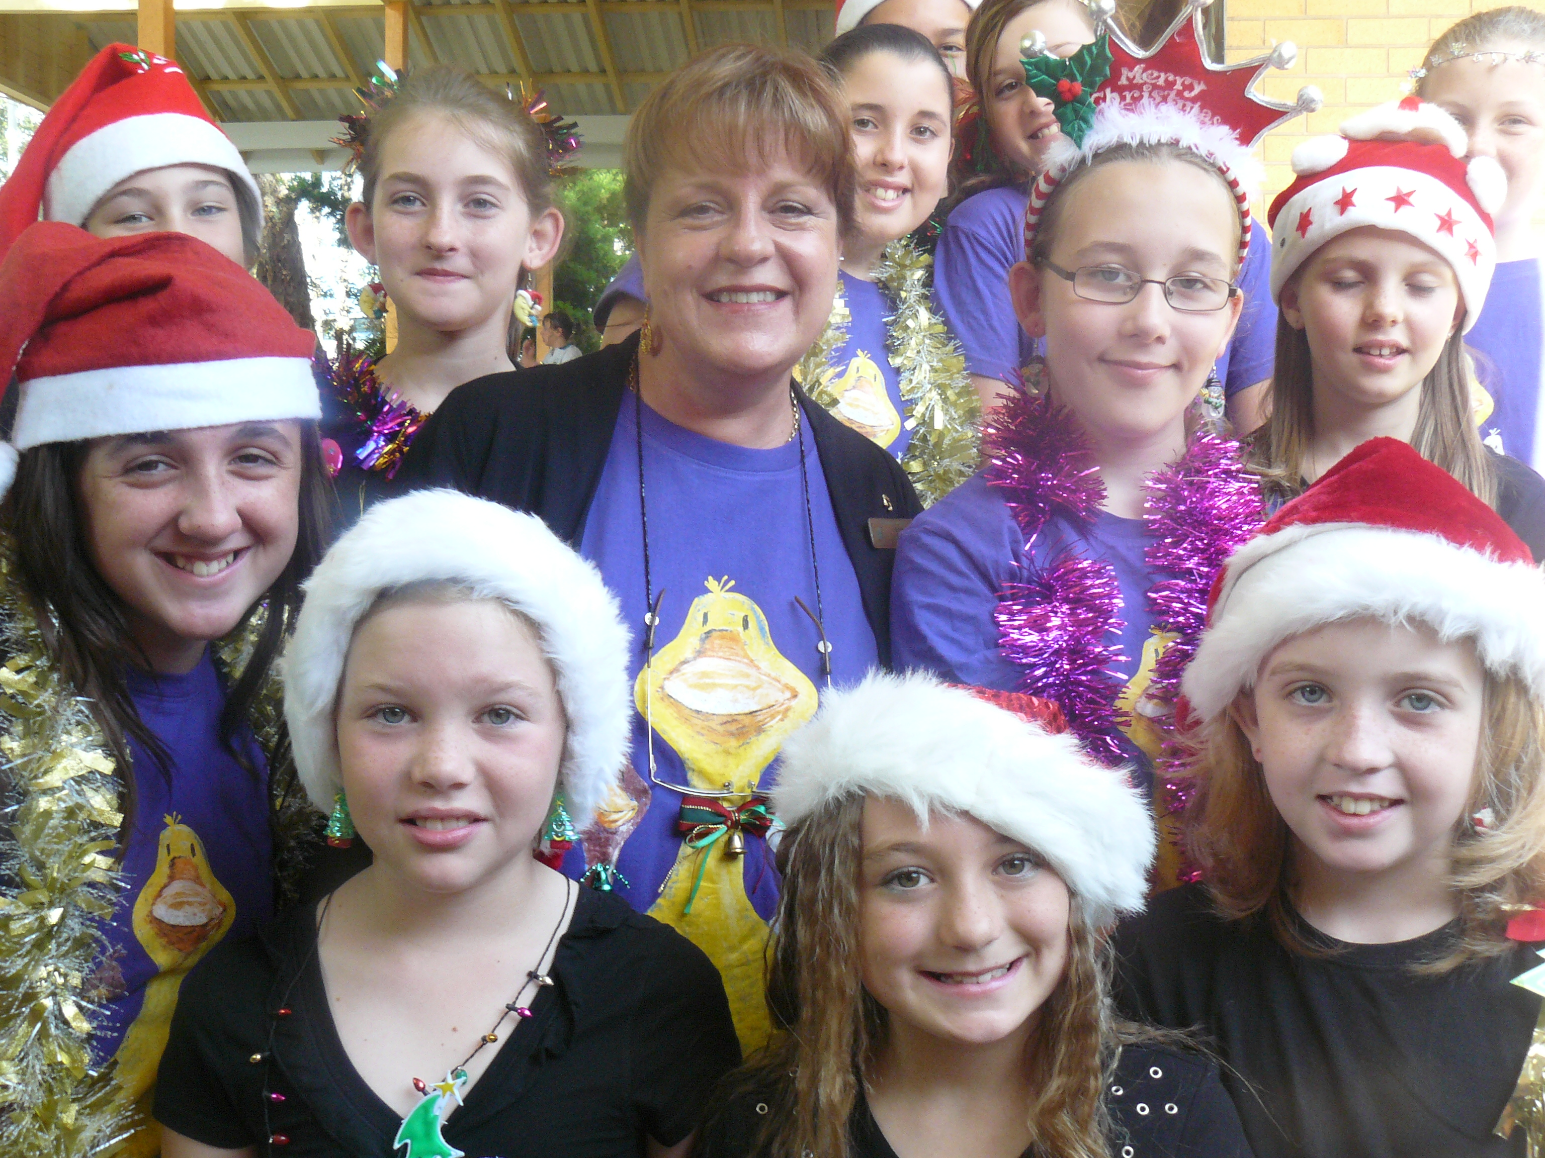

CHRISTMAS CHOIR

Our Christmas Choir visited Park Beach Plaza today and would like to thank our community for their generous donation of $274 and also Park Beach Plaza ‘Spirit of Giving’ for their donation of $500.


