TOORMINA PUBLIC SCHOOL

N E W S L E T T E R

NEWSLETTER 37/10 – Week 8, Term 4 – 2nd December 2010

Dear Toormina Families

Yesterday we held an afternoon tea to express our appreciation to the many parents and friends of our school who volunteer in assisting our staff to provide the best opportunities in the care and education of the children in our school.

All of our extra-curricula events which are so enriching to our students growth and development are dependent on the involvement and commitment of those who contribute their time and energy to the programs. Our social events, fetes, discos, etc are always well supported by our wonderful P & C and parents who readily make themselves available on these occasions. Parents also work in our canteen, classrooms and library. There are also numerous parents who assist in transporting children to various events of sport, creative arts and other excursions. Thank you for valuing and supporting the education of students of Toormina Public School.

Canberra Excursion – Stage 3 are having a wonderful time from our daily reports from Mrs Burns. We are hearing the weather is rather chilly and wet but this has not affected their program or fun. Mrs Burns assures us all the children will return with the added skills of maintaining ‘spotlessly tidy bedrooms’! This morning they were off to enjoy the cultural experience of the National Art Gallery having already visited ‘Old’ and ‘New’ Parliament House, the National Musuem and Black Mountain Tower. The bus is expected to return at 9.30 pm on Friday evening.

Presentation Day is a great opportunity to showcase our students success in 2010. We look forward to seeing many parents and family at both the Stage 1 and Stage 2/3 Assemblies.

Year 6 Farewell – hopefully our Stage 3 students will be recovered enough to have a wonderful evening together celebrating the closure of their journey through Primary School.

Our first Christmas event of the Season!

A combined Christmas Scripture Service will be held on Thursday. This is an opportunity for us to share in the spiritual values of Christmas. We thank our Scripture teachers for their dedication.

Christmas Annual Disco is also on next Thursday evening. We are looking forward to sharing the joy of Christmas through music and ‘dress up’.

Elaine Norman
Principal



TOORMINA PUBLIC SCHOOL
Truth and Tolerance

ADDRESS:
CAVANBA ROAD,
TOORMINA NSW 2452

TELEPHONE: (02) 6653 2122
FACSIMILE: (02) 6658 2287

EMAIL:
Toormina-p.school@det.nsw.edu.au

WEBSITE:
www.toormina-p.schools.nsw.edu.au

PARENTS & CITIZENS ASSOCIATION

P & C Committee meets
1st Friday of each month
9.15 am in School Staffroom

WHAT’S ON !

- Friday 3/12/10
Students return from
Canberra

- Monday 6/12/10
Luke Hartsuyker Visit,Stage 3,10 am

- Tuesday 7/12/10
Presentation Day
Stage 1 10 am
Stage 2/3 12 pm

- Wednesday 8/12/10
OC Orientation

- Wednesday 8/12/10
Year 6 Farewell

- Wednesday 8/12/10
Talent Quest

STUDENT AWARDS:

- Gotcha Being Good – Winners of this week’s “Gotcha Being Good” awards for demonstrating one of our school rules – Be Responsible

Darlene Barwise 3KC
Jacob Whitehouse 1/2H
Joshua Taylor 3KC
Tori Rose 3T
Kailah Johnson 4G

CONGRATULATIONS to the above students
(Prizes generously donated by Domino’s Pizza, Eagle Boys Pizza and the School Canteen – Thankyou!)

Club 1000

CONGRATULATIONS to the following achievers:

Nicholas Crutchfield KB

Club 2000

CONGRATULATIONS to the following achievers:

Mackenzie Davies KB

PRESENTATION DAY – Tuesday 7th December

Years K – 2 at 10.00 am,
Years 3 – 6 at 12.00 pm

Toormina Public School’s Hall

The end of year is fast approaching which means that our Presentation Day is nearing. Invitations to the parents and caregivers of children receiving an award went home with the children on Monday.

For parents who are attending both ceremonies, there will be tea and coffee available between the two.

UNIFORM: Please ensure that your child wears full school uniform on the day.

Jane Martyn, Assistant Principal

NORCO BOTTLE CAPS CAMPAIGN

A huge thank you to all the families
who have supported this fundraiser.

Our school has raised $810 this year.
This money goes to our SRC who will decide how it can best benefit our school.
So keep collecting those caps.
Each Norco milk cap = 10 cents for our school.

Children simply write their class and number (given by class teacher) onto caps with permanent marker. Caps go into a weekly draw to win a free pizza meal – thanks to our supporters:
Eagle Boys Pizza and
Dominoes Pizza (Toormina)

P & C NEWS
Hi everyone,

Our School Disco will be next Thursday 9th December. The cost for this will be $3.00 to cover the cost of the DJ.

Times are:
Stage 1 5.30 pm – 6.45 pm
Stage 2/3 7.00 pm – 9.00 pm

We will also be holding the Christmas Stall on the evening, so bring your purse and have a look. We have lovely gifts ranging in price from $2.00 - $10.00. Some great stocking fillers and gift ideas.

Christmas Carols by Candelight are also approaching very quickly. These will be held on the 14th December. We will also set up the Christmas Stall on this evening to give everyone the opportunity to buy some really great little gifts (I have my list made up already). We will also be drawing the Christmas Hamper Raffle on the night which leads me to my request of non-perishable items for the hamper. Some of the goods that have already come in include chips, biscuits, Christmas cakes, cans of food and some really beautifully made up Christmas puddings (great job!) to whoever made those up, they look lovely. We need lots more donations to make this a really big raffle! Anything you can donate will be greatly appreciated. (Please check the expiry dates).

The Raffle tickets for the hampers have gone home now and if you need more books you can get them from the office.

Hope to see everyone at our Christmas Carols by Candlelight and please bring your friends.
Thanks, Angela.

P.S. We will be needing volunteers for the evening for the BBQ and Christmas Stall so if you can help even for an hour, please call either myself, Angela on 66585137 or Toni on 66589949.



JOKE CORNER

How do horses tap out messages to one another?
They use horse code!
How does a snake hurry?
It gets a wriggle on?
Did you hear about the reformed koala?
It turned over a new leaf!
Which deer is always out of breath?
A pantelope?
What language do oranges speak?
Mandarin!

CANTEEN ROSTER

Friday 3/12.10 April Ingram, Jeanenne Shipman, Helen Ingram
Monday 6/12.10 Vacant
Tuesday 7/12.10 Taquita Garic
Wednesday 8.12.10 Stuart Darcy
Thursday 9.12.10 Toni Montgomerie

Penny Szafranski, Canteen Supervisor

DISCO – Thursday 9/12/10
The canteen will be selling some hot foods such as party pies, sausage rolls and mini hot dogs during the disco as well as the other “fun” foods we usually sell.
Penny Szafranski, Canteen Supervisor

BASKETBALL
The Basketball Committee would like to thank Donut King Toormina, Dominos Pizza Toormina and Eagle Boys Pizza Toormina for their kind donation of vouchers which we used as prizes at the school fete for the Basketball Shoot Out. We also had a face painting stall and the money we raised will go towards shirts for the 3 basketball teams.

A big thank you to all the parents and families who helped out on the day. Good luck to the teams who are playing in the semi-finals on Saturday 11 December.
The Basketball Committee

TOORMINA TIGERS ARE TERRIFIC!!
The basketball season is coming to an end and the Year 5&6 girls team have had a great season. The game last Saturday was one of their best performances. A great team effort and a well deserved win. Thanks to Mel Fraser for coaching the girls this year. The girls have had a lot of fun and thank you to the parents for your support. Congratulations to Kaitlyn, Mikayla, Emily, Bailey, Nioka, Maddy and Talei.

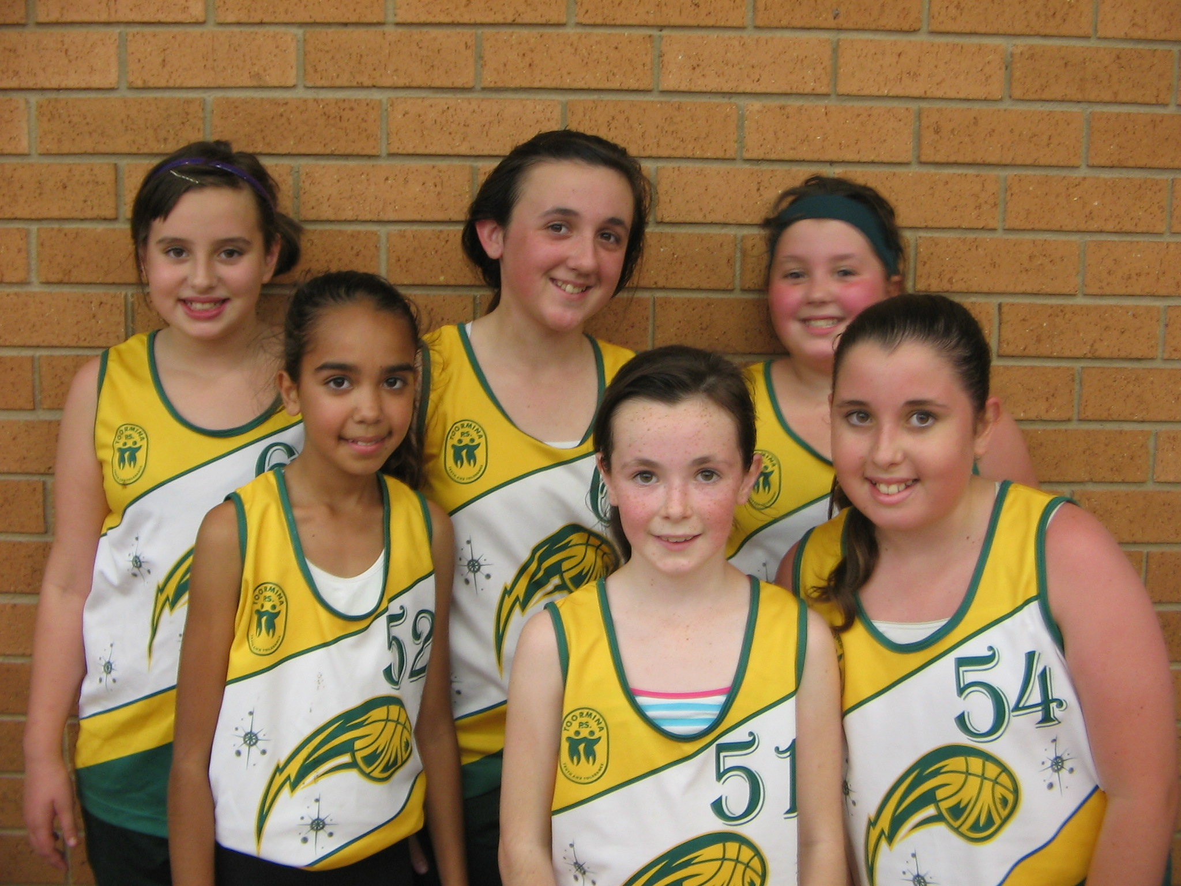

STUDENT BANKING
Congratulations on a wonderful year of School Banking! It is great to see lots of students saving regularly and collecting their Dollarmites tokens.

In Term 1 next year there will be some new and exciting reward items announced, which can be redeemed for 10 tokens each. Alternatively, your child can continue to collect 30 tokens to redeem for the backpack until the end of Term 2, 2011.

Please remember that the School Banking Rewards Program is designed to reward individual savings behaviour so no pooling of tokens will be accepted and for our school to receive commission deposits must be made through School Banking.

Next Tuesday, 7th December 2010 will be the last student banking for the year.
Debbie Cook and Stephanie Brady

P.S. On behalf of the parents and students at the school we would like to thank you for the time you spend at the school processing the student banking, it is most appreciated. Have a happy Christmas break and we look forward to seeing you next year.

HERE COMES SANTA CLAUSE – Coffs City Centre
Join us on Thursday 2 December from 5.30pm to enjoy a visit with Santa's live reindeer and the 3 Wise Men, see the South Sydney Rabbitohs, and help us welcome Santa as he arrives to turn on the lights on the City Centre Christmas Tree!

There will be jumping castle and face painting for the kids so head into our City Centre for a night of Christmas fun.'

Mr. Courtney Tune, CED & Event Coordinator



FREE fun program for kids to become fitter, healthier and happier

Do you have children 7 to 13 years old?
Are you worried they might be above their healthy weight?

The Go4Fun program helps kids get healthy and fit in only 10 weeks- and helps them stay that way! The program has been specifically designed for children aged 7-13 years and their parents.

Places on the Term 1 2011 program are limited, so call the Coffs Harbour Women’s Health Centre today on 66528111 or email your interest to sr.chwhc@bigpond.com to see whether your child qualifies and to get more details on how to register.



One to one tuition that builds on student strengths and weaknesses and promotes self-confidence in an encouraging and motivating environment.

“I assist students to reach their full potential”

Private Tuition K-6

Fully Qualified Primary School Teacher
Tuition in all areas of Maths and English, Homework and Project assistance.

Affordable rates. Mon—Fri

Contact Julie Kirkman 66585565 or 0431318683

COFFS HARBOUR WAR MEMORIAL POOL
On Wednesday December 1 from 4pm-7.30pm the Coffs Harbour War Memorial Pool will be 'officially' re-opened. Entry will be FREE to the public from 4pm including access to the brand new 25m Indoor Pool, completely refurbished 50m Outdoor Pool, and the all new Toddler Splash Pad. There will also be heaps of extra activities for all the family including Debra Lees Kidz Bizz, Face Painters, Jumping Castle, Coopers Swim Wear Fashion Parade, Celebrity Swimming Relay and a BBQ Fundraiser by the Masonic Lodge.
Mr. Courtney Tune, CED & Event Coordinator, Coffs Harbour City Council

CHRISTMAS FAMILY NIGHT

Bunnings Coffs Harbour
Thursday 2nd December 2010
6 – 8 pm
Come join in the fun
ITS FREE
Jumping castles, Lucky Door Prizes,
Santa Visit
Old Macdonalds Farm
Face Painting
Sausage Sizzle (Titivators for Breast Cancer)
Childrens DIY – Christmas Crafts
To register – contact 6650 7600
Or in store at the Service Desk

Sawtell Uniting Church
and
Sawtell Golf Club Ltd
invite you to attend

SAWTELL CAROLS BY CANDLELIGHT
Monday, 20th December 2010

Join us on the 9th fairway of the
Sawtell Golf club from 6pm
Bring a blanket and a picnic dinner or there will be food and refreshments available
from the club
Jumping castle and activities for the kids
Santa will be arriving at 7.30pm to start the Carols

DATES FOR THE DIARY ….

As the end of term draws to a close we have drawn up a calendar of events for your information:

- Friday 3/12/10 Students return from Canberra

- Monday 6/12/10 Luke Hartsuyker Visit – Stage 3, 10 am

- Tuesday 7/12/10 Presentation Day:
Stage 1 10 am
Stage 2 & 3 12 pm

- Wednesday 8/12/10 OC Orientation

- Wednesday 8/12/10 Toormina Talent Quest

- Wednesday 8/12/10 Year 6 Farewell, Sawtell RSL, 6 – 9 pm

- Thursday 9/12/10 School Disco:
Stage 1 5.30 pm – 6.45 pm
Stage 2 & 3 7.00 pm – 9.00 pm

Christmas Stall

- Friday 10/12/10 Year 6 Orientation to Toormina High School

- Monday 13/12/10 Stage 3 Pool Day

- Tuesday 14/12/10 Carols by Candlelight, 6 pm
Christmas Stall
Barbecue
Christmas Hamper Raffle to be drawn

- Tuesday 14/12/10 Stage 1 Movies

- Wednesday 15/12/10 Stage 2 Pool Day

- Wednesday 15/12/10 Last day of school for students

